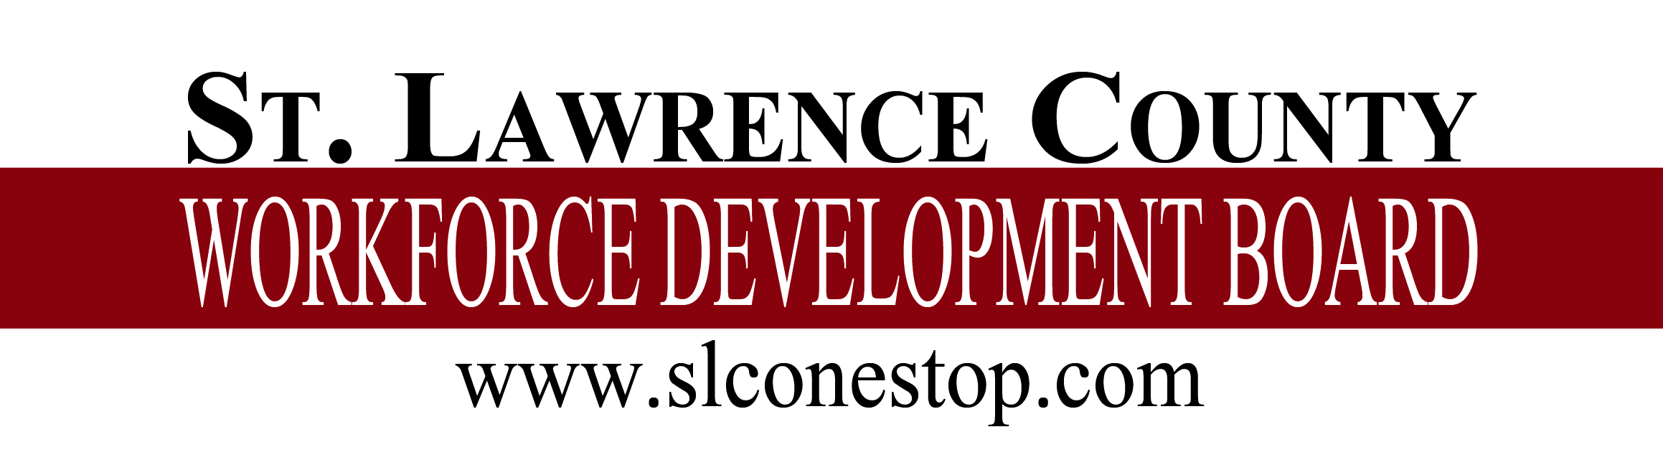

**Request for Proposal**

The St. Lawrence County Workforce Development Board has just released a Request for Proposal (RFP) for a **ONE-STOP NETWORK OPERATOR.** Proposals must be received by August 12, 2022 by 3 p.m. with services commencing on October 17, 2022.

For a copy of the RFP please call 315-386-3276 or visit our website at [www.slconestop.com](http://www.slconestop.com). EOE

C:\Users\jfree\Pictures\New folder\amerjobctr.png